# IT 230 Coding Activity Submission Template

Submit your work on the coding activities for Modules One, Two, Three, Four, and Six in this document. In addition to this document, you should submit a ZIP file containing all your Visual Studio project files and source code that can be run in Visual Studio on a different computer.

For each coding activity, complete the following steps:

* Download and rename this document to meet the file naming conventions requested in the assignment instructions.
* Fill in the required information below by replacing the bracketed text with the relevant information.
* Submit this document and your ZIP file for grading and feedback. Your ZIP file should follow the same naming conventions.

Document your work in the coding activity by completing each of the following items:

1. Provide a screenshot of the output that resulted from running your program successfully in Visual Studio. See the coding assignment instructions for an example of what should be included in the screenshot. Your screenshot must include the following elements:
   1. Your last name as the first printed text on the screen
   2. Verification that the program is fully functioning and data results are accurate for the given problem

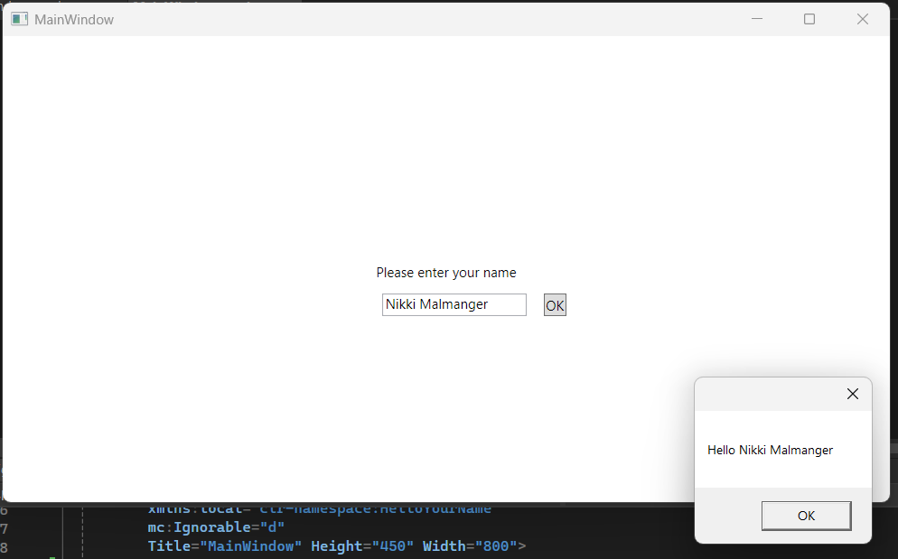

1. Copy and paste the source code text you wrote for this assignment from the *.cs file into the space below. Only providing the *.cs files or a screenshot does not meet the requirements for this part of the assignment. Code should be logically organized. It should also follow proper syntax and conventions noted in the Coding Activity Guidelines and Rubric.

using System.Text;

using System.Windows;

using System.Windows.Controls;

using System.Windows.Data;

using System.Windows.Documents;

using System.Windows.Input;

using System.Windows.Media;

using System.Windows.Media.Imaging;

using System.Windows.Navigation;

using System.Windows.Shapes;

namespace HelloYourName

{

public partial class MainWindow : Window

{

public MainWindow()

{

InitializeComponent();

}

private void okClick(object sender, RoutedEventArgs e)

{

MessageBox.Show($"Hello {userName.Text}");

}

}

}

1. Show that you understand the task by explaining the design of your program in the space below. Include the process and steps you took to write your code. Explain how you arrived at the solution to the problem and completed the activity.

The program is simply meant for the user to input a string of text, which the program will output a new window saying “Hello {user input}”. The first thing we must do is create a text block, then warp the transform to be as small as you can make it and align it to the center. Change the text within that block to say, “Please enter your name” (you may need to change the transform again after this).

Next, create a text box, warp the transform and align it under the text block. In the text box’s properties, change the name to “userName”.

Then, go to the toolbox one last time and create a button. Place the button to the right of the text box. Change the text within it to “OK” and warp the transform to be as small as possible but still be able to read the text. Then, go to the button’s properties and change the name to “btnOK”. Go to the event handlers within the button (the lightning bolt to the right of the wrench) and in the “Click” section write the name “okClick”.

Now, we can go into the .cs file and see the method, “okClick”. Within that method, type out “MessageBox.Show($"Hello {userName.Text}");”. Finally, save all your files and run it!

1. Reflect on your learning experience and what you learned from completing the activity.

I’ve never messed with WPF applications so there was a lot I learned about that. It reminds me of some of the website builders I see online where you can click and drag elements and change them to your liking. Though, the one on VSCode seems really finnicky and easy to make mistakes on. I don’t know how, but I ended up making a new method in the text box and I had to find a way to remove it from my application. XAML also reminds me of HTML with how they use brackets and close things in the program.